FOR IMMEDIATE RELEASE: January 30, 2016

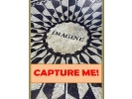Contact: Laura Bartnick, Partner at CAPTURE BOOKS,®
A Colorado Group Publisher
laurabartnick@aol.com 720.210.7107-cell https://www.facebook.com/CaptureBooks/
or type: Psalmhymns.Larkins in facebook

EVER WONDERED, WHAT WOULD A MODERN PSALTER SOUND LIKE?
Singable Psalm Lyrics, Set to Great Hymns of the Faith, are now available
as singers, God and scripture lovers will discover.

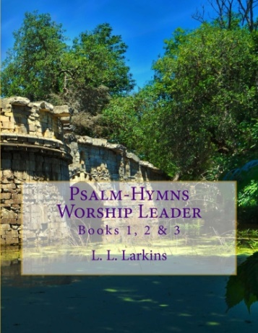
Capture Books,® is pleased to announce the release of a new psalter, an ancient worship guide to singable hymns. Psalm-Hymns Worship Leader brings singable Psalms to people of faith. Psalm-Hymns, Volume 1, translates the first 89 Davidic Psalms into accurate new lyrics from the ancient worship guide. Dramatic poetry, and uncensored human pleas during fears and tragedy in the odd silences of God, as well as transcending praises, reflect prescribed and authorized worship in melodies you recognize. Use for religious education, historical context, modern theater, church liturgy, praise & worship retreats, brain teasing memorization techniques and for story-telling.
Psalm (hyphen) Hymns, by L. L. Larkins is now available on Amazon.com as well as Kindle Books. Anchored-in-faith lyrics, with dramatic poetry, represent the first three biblical books of Davidic Psalms honed by Larkins over three years, that’s three years beyond college a degrees in music and Bible. Psalm-Hymns expressly describe the wonders of God during terrifying events, illness and betrayal, and God’s splendor in nature. They describe human relationships with God during life's miracles through the worshiper’s gratitude and hope.
Larkins believes Psalms are prescribed and authorized for worship throughout God's kingdom. "Psalms," in the Hebrew means "Praises." Let the message about the Messiah dwell richly among you, teaching and admonishing one another in all wisdom, and singing psalms, hymns, and spiritual songs, with gratitude in your hearts to God. Colossians 3:16 (HCSB)
Sing them a cappella or jazz them up, the content remains true to scripture and full of the Holy Spirit's power.
"What an amazing resource and tool for worship!” says Mike Flack, Owner/Operator of LaunchPad Studios and producer of YWAM’s School of Worship CDs. “This book can be used personally or corporately as a new collection of songs for worship, a small group study, or even a modern day hymnal."
Larkins’ hope is, by reciting or singing these Psalms, communities of faith are transformed by a new awareness of God's over-arching presence, intimate help and glorifying purposes in present situations.
Psalm-Hymns by Larkins is available now through Ingram, Baker & Taylor and Amazon-Kindle to bookstores, scholastic libraries, and at www.CaptureMeBooks.com

